|  |  |  |  |  |
| --- | --- | --- | --- | --- |
| **EMB000043d0be5d** | | **Data Convergence · Consumer Research Expert** | | |
| **ConsumerInsight Report** (Travel Report 2021) | | |
| Company | ConsumerInsight | | E-mail | kwonyg@consumerinsight.kr |
| Query | Kwon, Younggyo / Director | | Phone number | 02) 6004-7622 |
| Issued | Tuesday, Jan. 19th, 2021 | | Pages | Total of 4 pages |

|  |
| --- |
| **Warming up to the Idea of Overseas Travel,  but the Market Remains Cold**  **ConsumerInsight, 2016~2020 Analysis of Weekly Travel Behavior and Planning Study** |
| * Interest in overseas travel, which fell after COVID-19, has gradually rebounded |
| * ‘South Pacific’ most preferred as a ‘contactless’ destination to relax in a quiet place |
| * USA and Canada, with a significant number of infections, are slow to recover |
| * Suppressed travel spending due to economic difficulties...  Expected to be difficult to return to the past |

Koreans’ interest in overseas travel, which fell by half and reached its lowest point in July after the COVID-19 outbreak, is gradually recovering. A subtle change occurred in overseas travel sentiment, with a preference for the South Pacific Ocean regions over Europe. Interest in traveling to short-distance destinations such as Japan, Hong Kong/Macau have also recovered rapidly. However, it would be difficult to expect travel behavior to recover to “before COVID-19 era” levels as, in addition to COVID-19, another negative factor, economic sluggishness, remains.

ConsumerInsight, a travel research specialized firm, analyzed the degree of interest (5 points scale, percentage of interest that is “largely” (5 points) or “slightly” (4 points) increased) in overseas travel destinations for travelers in the ‘Weekly Travel Behavior and Planning Study’ (500 per week, 26K per year). The survey asked for 12 destinations including ▲China ▲Japan ▲Hong Kong/Macau ▲Southeast Asia ▲Middle East/Southwest Asia ▲USA/Canada ▲South America/Latin America ▲Western Europe/Northern Europe ▲Eastern Europe ▲Southern Europe ▲South Pacific (Australia, New Zealand, Guam, Saipan, etc.) ▲Africa, and the results since 2016 were used.

**■ Only 19% of “increased interest in overseas travel” in 2020... Marking half of the 2016 rate**

Since 2016, Korean travelers' interest in overseas travel has continued to be positive, with short-distance travel destinations such as Southeast Asia and Japan as the primary go-to countries, but the rate declined in 2019. The rate in 2019 was down by 4%p from its previous year to 32%, affected by the ‘Boycott Japan’ movement and the Hong Kong protests **[Table 1]**. Last year, it was only 19% due to the aftermath of COVID-19, which was nearly half of its rate of 37% in 2016.

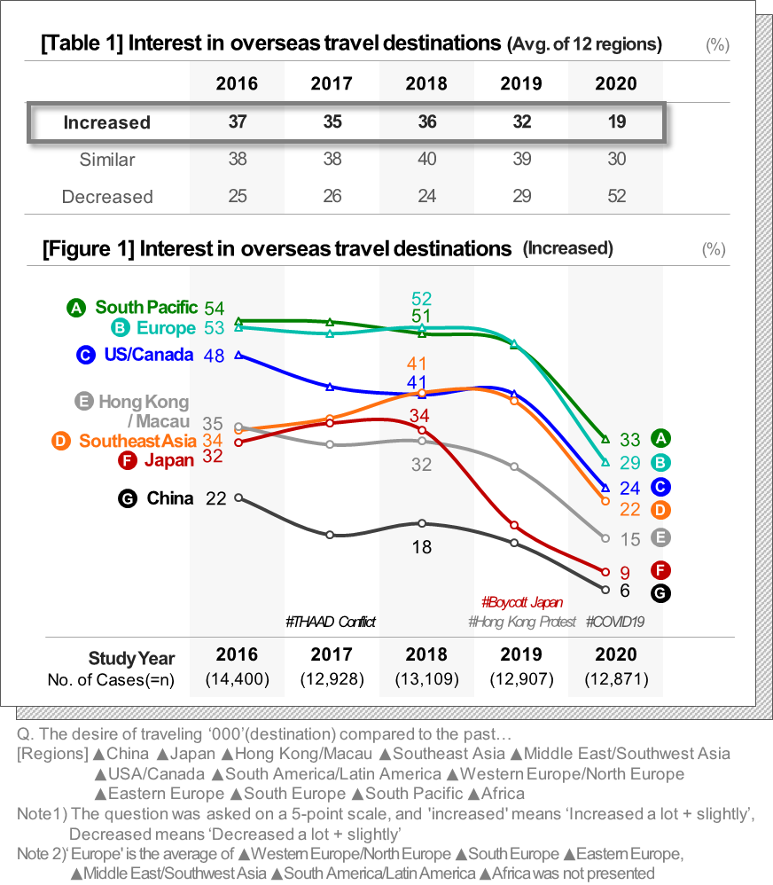

By region, ▲South Pacific and ▲Europe recorded 50% in travel intention rate every year until 2019. These regions were selected as the most preferred tourist destinations by Korean travelers, but the rate declined to 33% and 29%, respectively, last year **[Figure 1]**. Due to the pandemic in Europe, the 1-2% gap between the two regions widened to 4%p. With the most COVID-19 confirmed cases globally, the intention of traveling to ▲USA/Canada (24%, down by 17%p from last year) also marked 3/5 of the previous year’s rate, showing no hope of returning to the same level as before.

Dynamic changes have been observed in Asian travel destinations since 2016. The intention to travel had already plummeted before the COVID-19 outbreak to ▲China from THAAD conflict in 2017, to ▲Japan from the boycott movement in 2017, and to ▲Hong Kong/Macau from protests in 2019. ▲Southeast Asia, on the other hand, has become Asia's top travel destination thanks to its weak neighboring regions and increased flights, but has been hit the hardest by COVID-19 in Asia.

**■ Has the ‘Boycott Japan’ movement weakened? Japan, the only country with increased travel interest**

The monthly interest level in 2020 reached its lowest point in July, but then continued to rise gradually. In December, when the first vaccinations in the United States began, the level of interest was on average 19%, up by 6%p from July **[Figure2]**.

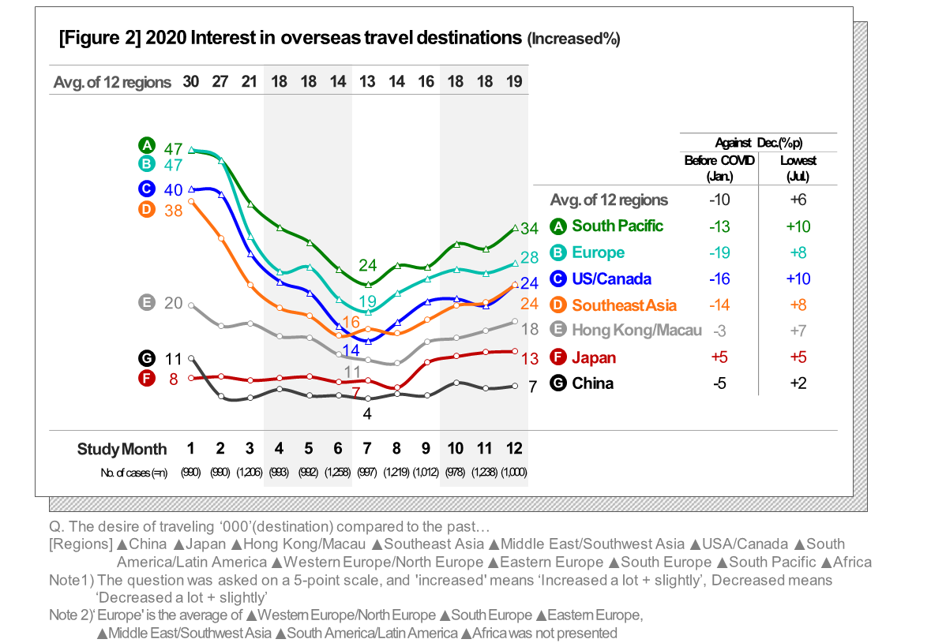

When comparing January just before the pandemic to the latest December, the numbers differ according to the regions’ COVID-19 spread. The interest in traveling to the South Pacific, a clean and recreational destination, declined by 13%p while the rate in Europe and the United States/Canada, where the number of infections surged, declined by 19%p and 16%p, respectively. Hong Kong/Macau has approached its pre-COVID-19 level due to establishing a quarantine system and discussions on a travel bubble, and Japan is the only country with a higher level of interest compared to last January, making it appear as though the ‘Boycott Japan’ movement has halted.

**■ Short-term, close distance & relaxing traveling trends to follow**

Interest in overseas travel is gradually increasing, but overseas travel is unlikely to happen even if the COVID-19 vaccines are available to the general public. The economy is the critical obstacle. Consumers could feel the effects from economic deterioration even before the pandemic, and travel spending was the top priority to reduce among all expenditures.

In fact, according to ConsumerInsight's Perceived Economy Study, the consumption expenditure outlook index averaged 79.2 points in December, down by 11.4 points from January while the travel expenditure outlook index decreased by 32.6 points to 51.8 points in the same period. ([Reference. ConsumerInsight perceived economy study index(KOR)](https://www.consumerinsight.co.kr/cpes/)). 50 points in the index signifies that there would be no one who would increase their travel expenditures.

The reopening of skyways is closely related to the vaccine supply. Only those who have been vaccinated will be able to travel to vaccinated countries. After that, travel destinations will be decided upon based on preferences. Considering that cash-strapped travelers are likely to avoid Europe or South Pacific countries, they will seek closer destinations. Also, consumers will be reluctant to travel to countries with political conflicts such as China, Hong Kong, and Japan, and countries in Southeast Asia are emerging as an alternative. Overseas travel will also resemble the domestic travel trend focusing on short-term, short-distance, and relaxing travel.

For the same reason, there is a high possibility of an increase in domestic travel instead of overseas. If the requirements for revitalizing domestic travel are met in a timely manner when overcoming COVID-19, it could be a new opportunity to grow the domestic travel industry.

|  |
| --- |
| [**Want to know about #Travel Issues related to this report?**](https://www.consumerinsight.co.kr/etravel/outline3.aspx) |
|  |
| This result is based on the 'Weekly Travel Behavior and Planning Survey' conducted by the ConsumerInsight tourism industry research lab on 500 travel consumers every week (26,000 annual surveys). The weekly updated survey results and analysis reports can be viewed at [https://www.consumerinsight.co.kr/etravel](https://www.consumerinsight.co.kr/etravel/main.aspx) and the summary of the survey results of years 2018 and 2019 are downloadable. ([Download Reports](https://www.consumerinsight.co.kr/etravel/download.aspx))  ConsumerInsight provides professional and scientific research services required in various industries such as automobiles, mobile communications, shopping/distribution, tourism/travel, and finance through large-scale online panels that are efficient for non-face-to-face research. In particular, in recent years, ConsumerInsight is focusing on increasing the data value and applying it to various industries by linking big data panel research data to the convergence data. |

Copyright ⓒ ConsumerInsight. All rights reserved. Cannot be used for commercial purposes.

|  |  |  |
| --- | --- | --- |
| **For-more-Information** | | |
| Kwon, Younggyo / Director | **E.** [kwonyg@consumerinsight.kr](mailto:kwonyg@consumerinsight.kr) | T. 02)6004-7622 |